Spatial transcriptomic analysis of the developing human pancreas
G.D. Jackson¹, M. Gierlinski², J. Cantley¹
¹Division of Diabetes, Endocrinology and Reproductive Biology, School of Medicine, University of Dundee, ²Computational Biology, School of Life Sciences, University of Dundee, Dundee, UK
Background and aims
Deeper insights into human pancreatic development have the potential to improve our understanding of beta cell formation, to enhance stem cell to beta cell differentiation protocols, and to inform efforts to regenerate pancreatic beta cells in vivo. Advances in spatial transcriptomic (STseq) technology provided new insights into the developing human pancreas from 12+ weeks post-conception (PCW), although have not achieved cell-level resolution. In this present study we apply transcriptome-wide, cell-level-resolution STseq to the developing human pancreas at 8PCW, a timepoint characterised by high endocrine progenitor activity and beta cell differentiation.
Materials and methods
Through the MRC/Wellcome Trust Human Developmental Biology Resource (project 200730) we obtained 8PCW human embryonic pancreatic tissue from 6 donors. Immunofluorescent (IF) staining for NKX6.1 and insulin identified intact embryonic pancreatic sections. STseq of two pancreata using the 10x Genomics Visium HD workflow enabled analysis of > 31,000 8 µm bins per tissue using 10X Loupe Browser and visualisation of transcriptomic clusters.
Results
STseq was completed at a sequencing depth of 71,224 reads/mm² for sample 1 and 44,205 reads/mm² for sample 2. This resulted in >12,960 genes detected per sample. Unsupervised clustering of the data revealed a cluster with highly upregulated expression of pancreatic endocrine markers INS (p=2.60e-127), GCG (p=2.11e-52), SST (p=1.57e-32) and GHRL (p=1.74e-45) and the endocrine progenitor marker NEUROG3 (p=1.07e-51). This aligned with INS+ regions of IF imaging of adjacent sections. A second cluster with upregulated NEUROG3 expression (p=6.39e-42) was identified, but with lower INS expression (p=3.78e-6), suggesting endocrine progenitor status. The anatomical spatial map revealed the endocrine dominant cluster being surrounded by the potential progenitor mantle cluster in the spine of 8PCW pancreas.
Further anatomically distinct clusters were associated with non-endocrine pancreatic tissue (NKX6.1+ but negligible endocrine marker expression), nervous system (DBH, PRPH, GAL and GAP43 p<1.82e-223), endothelium (VWF p<1.21e-53 ), vascular smooth muscle (MYH11, TAGLN and ADIRF p<7.20e-90), immune (LYZ, S100A9 and LTB p<2.79e-97) and extracellular matrix (COL16A1, LUM and POSTN p<3.05e-18).
Conclusion
These data provide unprecedented anatomical resolution of the embryonic pancreas transcriptome at a critical time point for beta cell neogenesis, along with insights into tissue architecture relating to regions of endocrine cell differentiation, progenitor status and other cell types.
Supported by: Type 1 Diabetes Grand Challenge (Senior Research Fellowship); University of Dundee School of Medicine.

Disclosure: G.D. Jackson: None.

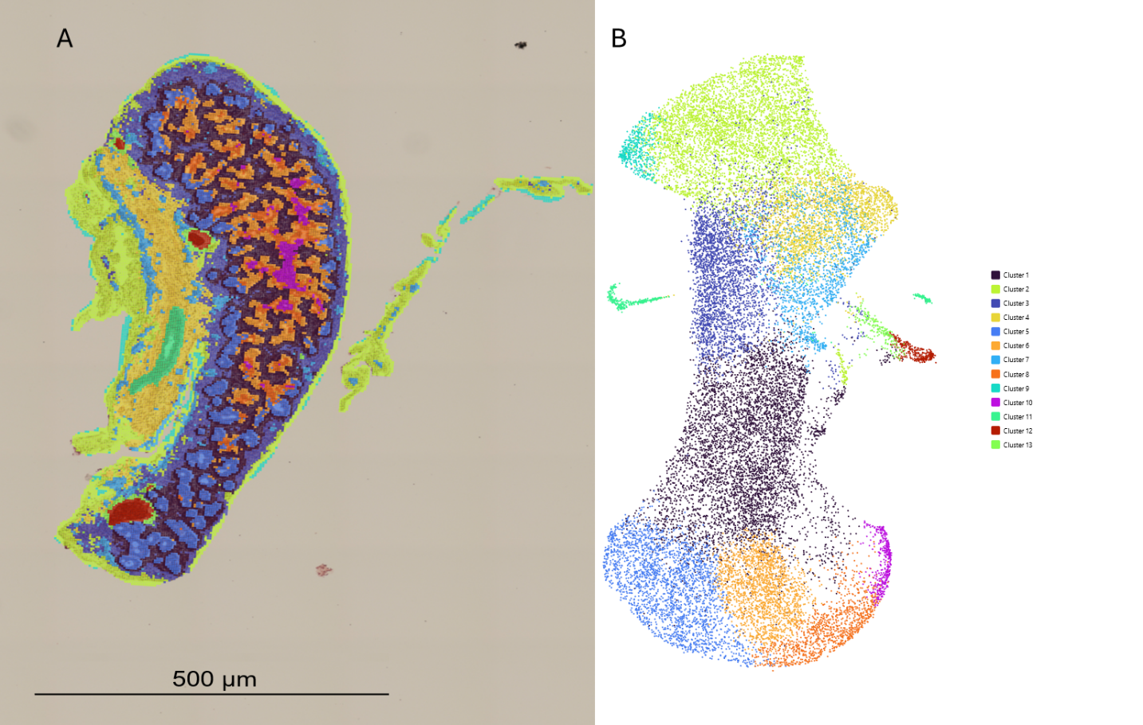
Figure1. A) Clustering of 10x Genomics Visium HD sequencing overlayed onto H&E stained tissue. B) Illustrates the clustering in UMAP form.

